- Home
- Subscribe
- Computer controlled grow box
- Upside Down Tomato Planter
- LED Growbox
- Forum
- Contact

How to make a cheap soil moisture sensor – Heavy Duty Version
cheap, electronics, moisture sensor, water
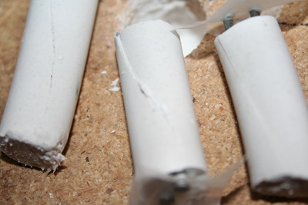
My original version of my moisture sensor has worked great for me but it did have a couple flaws. The first issue was construction, though I had great luck on my first attempt though after trying to recreate additional sensors given the small amount of gypsum between the sensor and the probes were so thin it was extremely easy to crack the sensor and I normally have about a 25% success rate on later creations (must have had beginners luck on the first one.
The second issue was durability. Given we are playing with gypsum and as it is suspended in water it will eventually breakdown and there is very little we can do about it. Though with my latest changes to my automated grow box which includes automated watering based on moisture content I want to ensure my measurements stay accurate throughout the season. To help with this I have decided to increase the sensors size and also am using galvanized nails to prevent rusting. After a few attempts I have come up what I feel is a pretty foolproof method of creating a moisture sensor.

How it works:
There were many questions in the comments in the previous post so hopefully I can clear this up a little here.
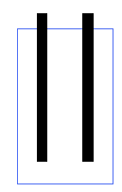
Technically a gypsum block measures soil water tension. When the gypsum block is dry it is not possible for electricity to pass between the probes, essentially making the probe an insulator with infinite resistance.
As water is added to the problem more electrons can pass between the probes effectively reducing the amount of resistance between the problem to the point when it is fully saturated where the probe has virtually zero resistance. By using this range of values you can determine the amount of water than exists in your soil.

Parts:
- Plaster of Paris
- 2 Galvanized Finish Nails
- 1/2 inch plastic tubing
- utility knife
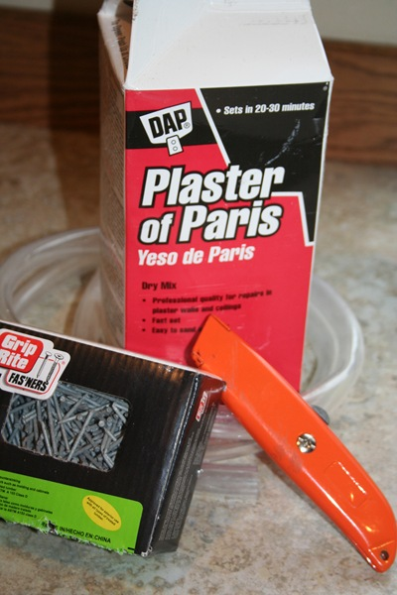

Construction:
Take your utility knife and cut the tubing slightly longer than your galvanized finishing nails. Try to make the cut as straight as possible though it doesn’t have to be completely perfect.
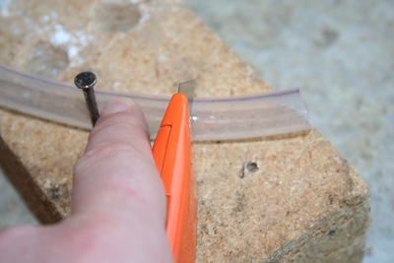
Use your utility knife to cut the smaller plastic tube lengthwise, this will allow easier removal of your soil sensor after the mold cures.
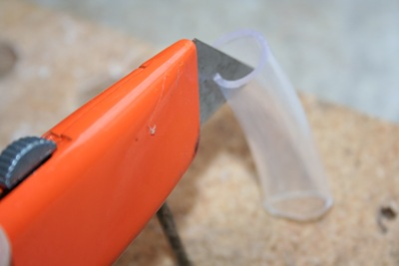
Optional: Make the cut diagonally to prevent a potential vertical fracture line.
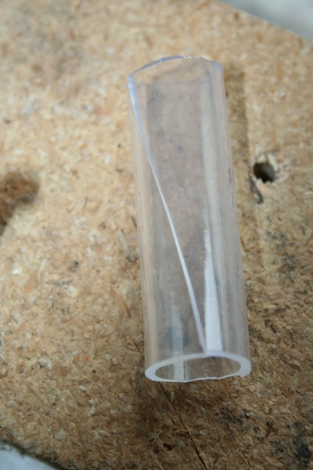
If you were very careful on you vertical cuts you can avoid this step, but to completely avoid spilling plaster onto my workbench I drilled four holes slightly larger than your tubing. I used these holes for support but also to catch any of the plaster in the gaps from you less than accurate vertical cuts.
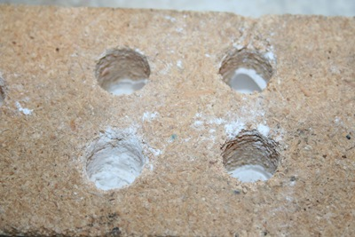
Being careful that the tubing fits together where you split the tubing vertically, insert the tubes into the holes (or carefully on a flat surface) Mix Plaster of Paris and carefully fill with to the top. The friction between the tubing should keep a water tight seal where you made the cut, though if the plaster is a little thin and it appears to be leaking through wait a couple minute for the plaster to setup some and try again, at that time it should not have the viscosity to seep through the very small gap that may be causing the leak.
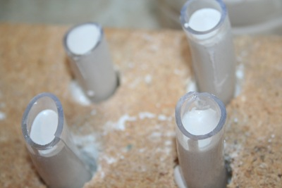
Take your two galvanized nails and push them through a small piece of wax paper. You may also allow the plaster to setup for a few minutes and then float the nails in the the plaster. I like the first method since gravity will help ensure they fall straight down and parallel to each other. As for spacing, I have done some experimentation with the gaps between the probes and my conclusion was, it doesn’t make much difference. As long as there is a gap (they are not touching) you should get reliable results.
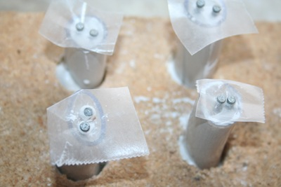
After allowing the sensor to cure for about and hour remove it from the holes you drilled in the wood.
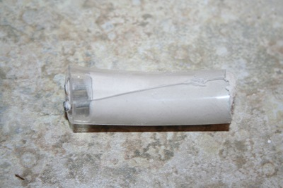
Gently pull back the plastic tubing and you have a nice clean soil sensor.
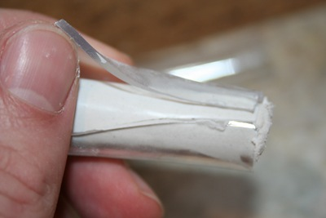
Lay them out to dry for 24 hours to cure completely and their construction is complete.
For attaching the wires there are a couple options. The best would be to solder them to the probes though to do this you need to heat up the nail hot enough to enable a strong solder connection. My little 15W soldering iron just can’t produce the heat for this so I am option for the wire wrap method. I take about an inch of wire and strip off about an inch of insulation and tightly wrap around the probe. Given copper will rust and could be a point of failure you will want to insulate this connection and the probes from the moisture. A few dabs of hot glue works pretty well. I am planning on trying liquid plastic, though I am currently out and when I have some on hand I will update with how it went.

How to use it
You can simply hook up a multi-meter and check the resistance though if you want to create anything automated you would need to use an integrated circuit (IC) or a electronics prototyping platform such as Arduino. By applying voltage to one side of the sensor and using a voltage splitting circuit connected to ground and an analog input you can then measure the voltage making it through the probe. The higher the voltage, the higher the moisture content of the soil.
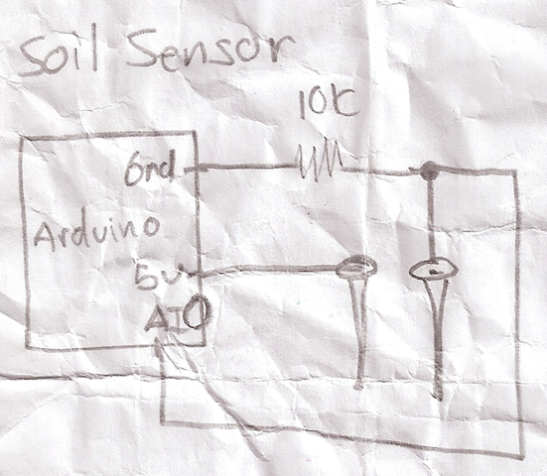

Conclusion
The above should give you everything you need to know to create your own soil sensor and how to use it. This can be used as a soil sensor for watering your indoor plants like I am using it. This same sensor could be for monitoring your outside soil moisture content to trigger (or preempt your irrigation system) to save some money on your water bill and/or maintain consistent moisture levels in your plants which could drastically improve water sensitive crops such as tomatoes.

